Alex Cubley
Durant High School
Division 8

Keeping Members Involved

I plan on keeping the new Key Club members involved by being an example of how much fun it is to help others. Helping others is beneficial because it connects you to your passion. You can find what type of volunteer work brings out what you love to do. I have discovered I love working with kids thanks to volunteering at an elementary school. Key Club offers a range of volunteer work from elementary schools, to our own high school. Members will be given the opportunity to feel passionate about what makes them feel needed and wanted; when the new members realize they are watching the community grow, they will want to be apart of it! The members will be happy to serve with smiles. The effort dedicated to making a difference will encourage others to be involved with other projects. I will be signing up for as many service projects while encouraging others as well in hopes of boosting morale. With the team's spirits up, more people are likely to sign up for projects. Volunteer work is normally with other people. This helps build social skills and friendships. You can take the skills you build with you on your journey through life. It's a wonderful feeling to know that you aren't the only person willing to work to make a difference around you. Being apart of a great organization like Key Club makes you feel important. The new members will want to stay involved because they feel needed.

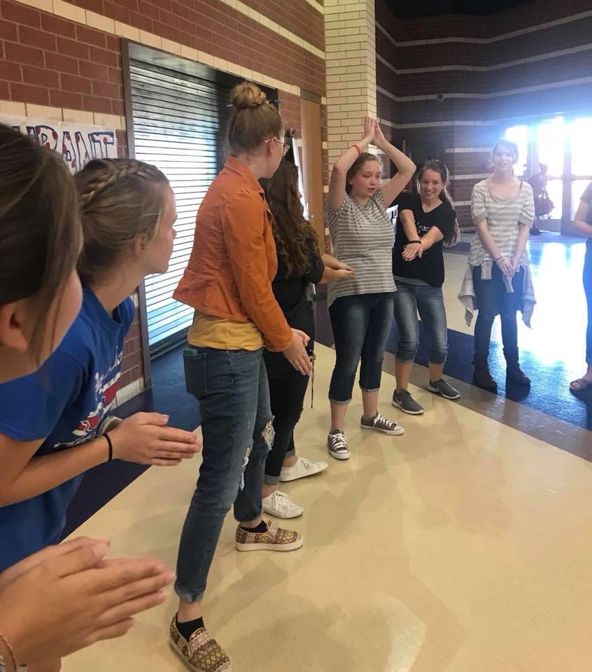 Members feel included playing a fun game

